A Recipe For:

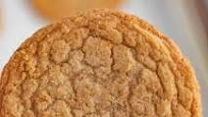 

# 

# Brown Sugar Cookies

**From the Kitchen of:** Grandma Williams

**Servings:** 3 dozen

**Prep Time:** 20 minutes **Bake Time:** 15 min **Bake Temp:** 325

**Ingredients:**

* 1 cup butter or margarine
* ½ cup brown sugar
* 2 cups flour
* 1 tsp vanilla

**Instructions:**

Cream butter and sugar. Add vanilla, then flour. Roll into balls. Thumbprint – if desired. Add red hots, chocolate kiss, nut, colored sugar or whatever. Bake on greased cookie sheet at 325 for approximately 15 minutes.